MIMO 4x4 Demo Configuration Guide
This is a rough guide to setting up a 4x4 MIMO demo. Refer to the 2x2 demo and config guides for more detail.
The configuration includes 4 VSGs in 1 chassis, and 4 VSAs in a second chassis.
VSGs in slots 2,6,11 and 15
Ref slot 10

Chassis 2: 4 VSAs

VSAs in slots 3,7,12 and 16
Ref slot 10

There are two ways to operate the two chassis:
- Using two separate controllers. In this case, you will run the M9381A MIMO Demo Tool on one controller that is connected to the VSG chassis. On the second controller, you will run 89600, and you will need to manually route the triggers on the backplane for the VSA chassis.
- Using a single controller to control both chassis. Follow the instructions from the web. There is a chtml file that can be downloaded that describes several ways to connect multiple chassis. Any of these methods can be used. The best performance will be with a high performance desktop controller with a STAR configuration to the two chassis.
http://www.home.agilent.com/agilent/editorial.jspx?cc=US&lc=eng&ckey=2359963&nid=-11143.0.00&id=2359963

To set up VSGs
Run self test, save IVI config entries (no reference)
Before run self test, must route triggers on backplane of the VSG chassis:
For VSG 2:
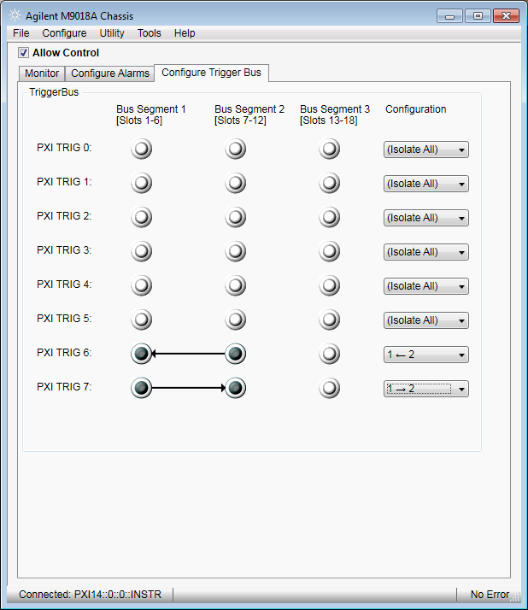

For VSG 4:
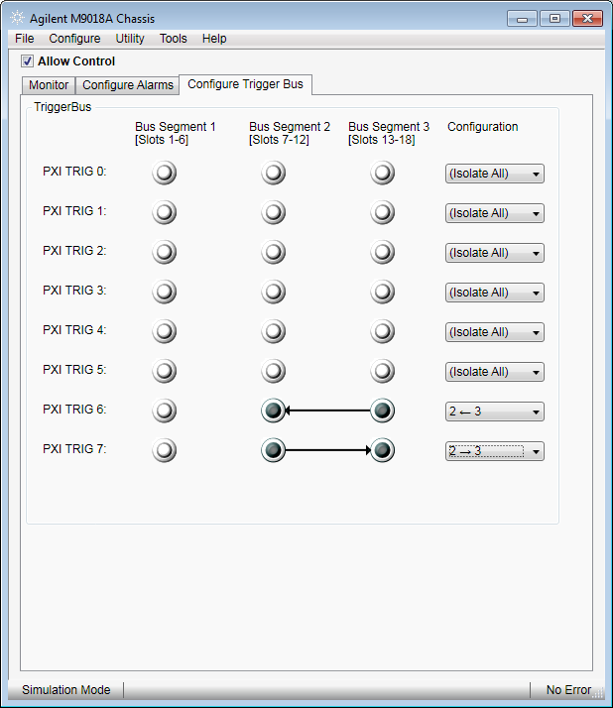

Note: these will be different when running all VSGs simultaneously. Demo program will take care of

VSA: Run self tests on all 3 VSAs
To test 89600, route triggers on the VSA chassis:
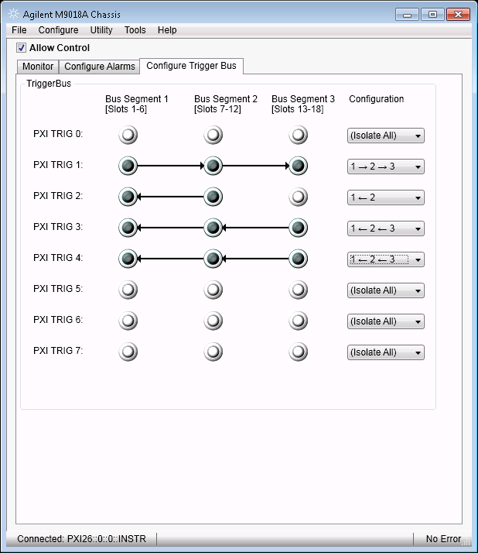

Or run this as a Command Expert script or other program:

M9018vsa.TriggerBus.Connect(1, Agilent.AgM9018.Interop.AgM9018TrigBusEnum.AgM9018TrigBus1To2To3);
M9018vsa.TriggerBus.Connect(2, Agilent.AgM9018.Interop.AgM9018TrigBusEnum.AgM9018TrigBus2To1);
M9018vsa.TriggerBus.Connect(3, Agilent.AgM9018.Interop.AgM9018TrigBusEnum.AgM9018TrigBus3To2To1);
M9018vsa.TriggerBus.Connect(4, Agilent.AgM9018.Interop.AgM9018TrigBusEnum.AgM9018TrigBus3To2To1);

Create VISA alias for chassis’.
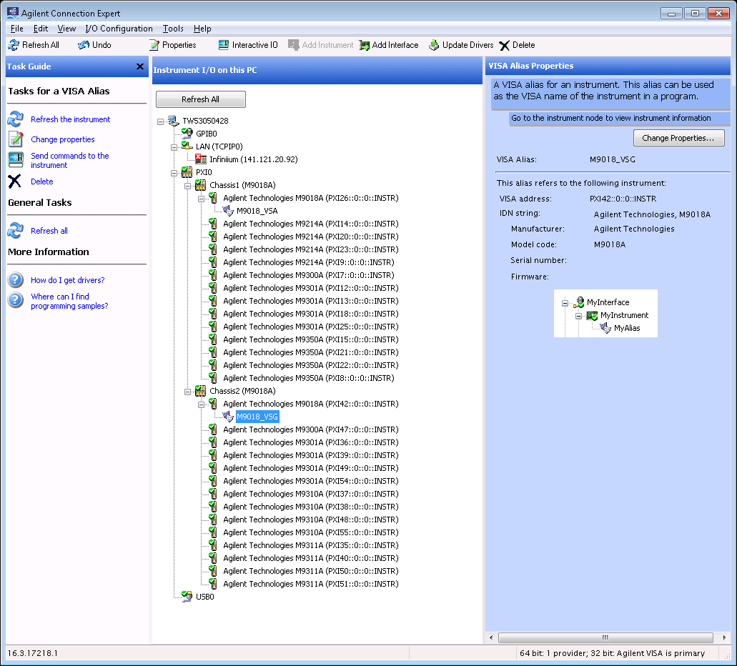

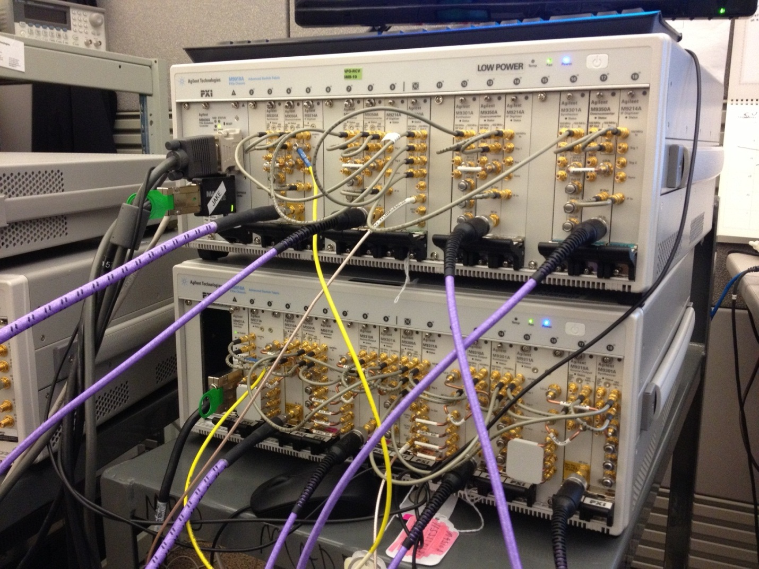

4x4 80 MHz Single Stream
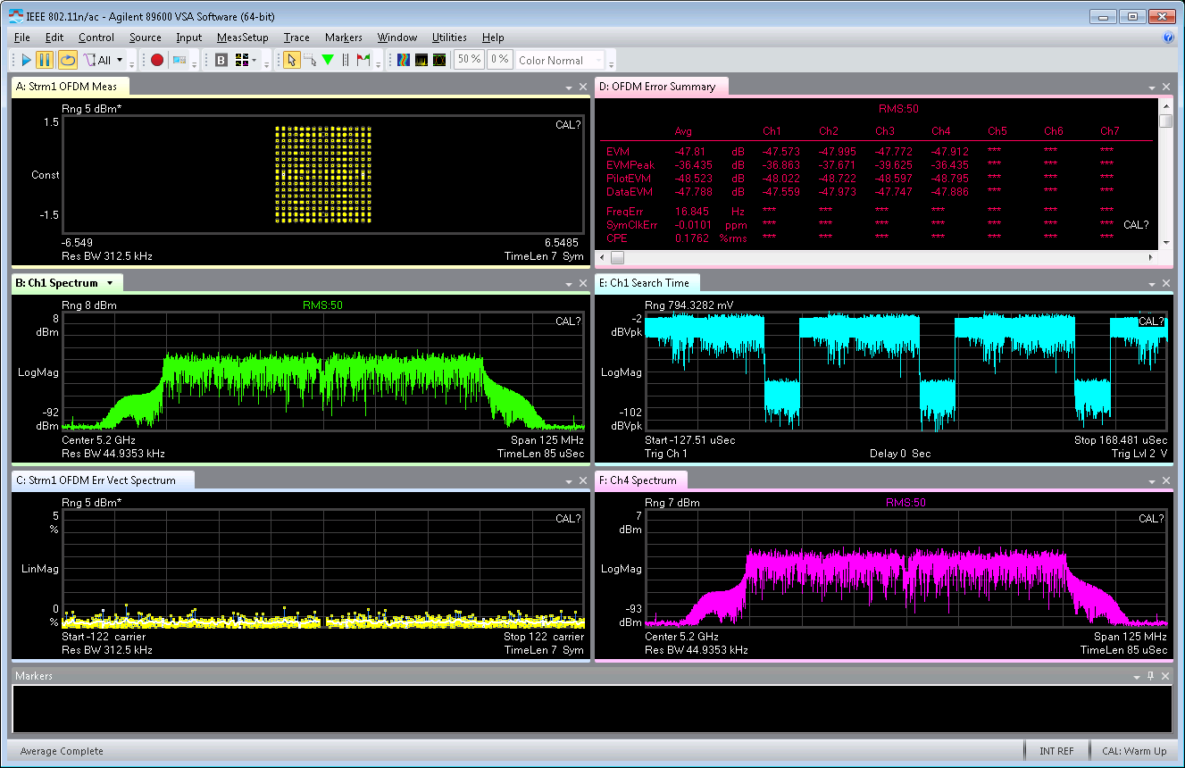

4 stream 80 MHz BW

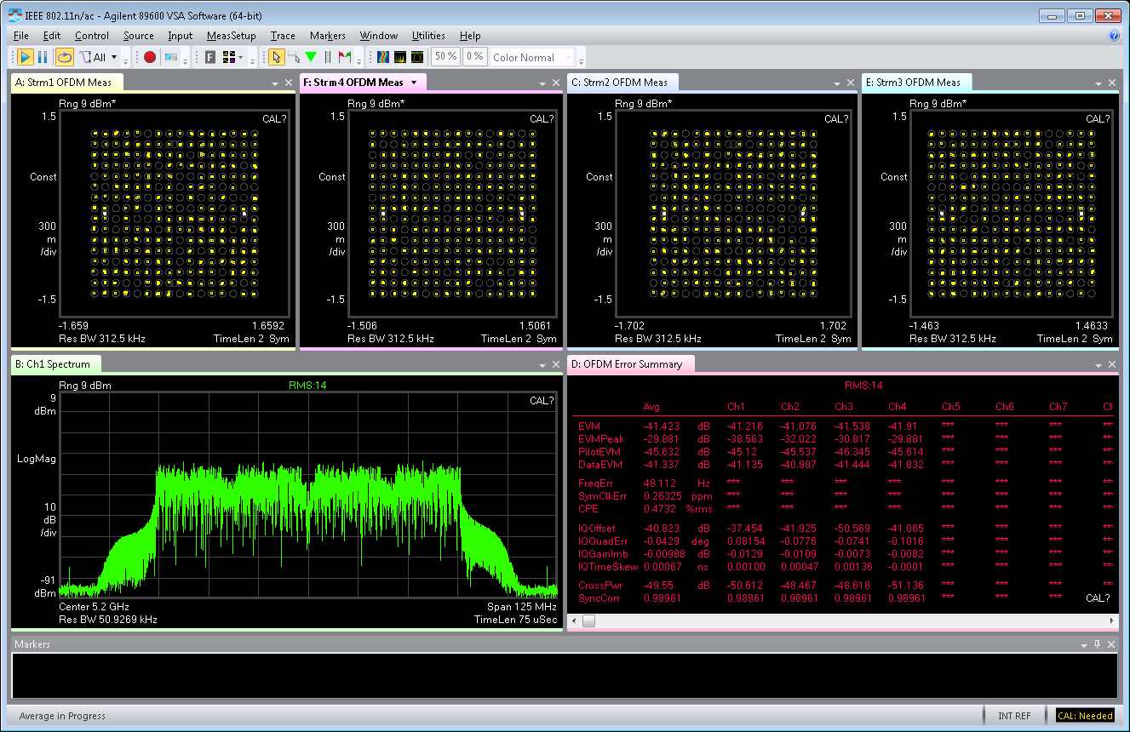

Note the MIMO M9381A Demo Tool works for a 4x4 configuration. Set Number of Channels to 4, and ensure the VISA resource strings match the hardware configuration.
